A
Real-Time Research Project On
APPLICATION OF RFID TECHNOLOGY AND THE MAXIMUM SPANNING TREE ALGORITHM FOR SOLVING VEHICLE EMISSIONS IN CITIES ON INTERNET OF THINGS
(Submitted in partial fulfillment of the requirements for the award of Degree)

BACHELOR OF TECHNOLOGY
In

COMPUTER SCIENCE AND ENGINEERING
By

Wasil Ahmed (247R1A0566) M.Sindhu (247R1A05A1)
G.Rishi (247R1A0584)

Under the Guidance of

Dr. K.Maheshwari
(Assisstant Professor)


DEPARTMENT OF COMPUTER SCIENCE AND ENGINEERING
CMR TECHNICAL CAMPUS
UGC AUTONOMOUS
(Accredited by NAAC, NBA, Permanently Affiliated to JNTUH, Approved by AICTE, New Delhi)
Recognized Under Section 2(f) & 12(B) of the UGCAct.1956, Kandlakoya (V), Medchal Road, Hyderabad-501401.
April, 2026.

DEPARTMENT OF COMPUTER SCIENCE AND ENGINEERING


CERTIFICATE

This is to certify that the project entitled “APPLICATION OF RFID TECHNOLOGY AND THE MAXIMUM SPANNING TREE ALGORITHM FOR SOLVING VEHICLE EMISSIONS IN CITIES ON INTERNET OF THINGS” being submitted by Wasil Ahmed (247R1A0566), M.Sindhu (247R1A05A1) & G. Rishi (247R1A0584) in partial fulfillment of the requirements for the award of the degree of B.Tech in Computer Science and Engineering to the Jawaharlal Nehru Technological University Hyderabad, during the year 2025-26.

The results embodied in this thesis have not been submitted to any other University or Institute for the award of any degree or diploma.

Dr. K.Maheshwari Dr. Nuthanakanti Bhaskar Assisstant Professor HoD
INTERNAL GUIDE

ACKNOWLEDGEMENT
We take this opportunity to express our gratitude to the people who have been instrumental in the successful completion of this project, we take this opportunity to express our profound gratitude and deep regard to our guide Dr. K. Maheshwari, Associate Professor for his exemplary guidance, monitoring and constant encouragement throughout the project work. The blessing, help and guidance given by him shall carry us a long way in the journey of life on which we are about to embark.

We take this opportunity to extend our heartfelt appreciation to the Project Review Committee (PRC) Coordinators—Dr. J. Narasimharao, Ms. G. Swathi, Mr. G. Pavan Kumar and Mrs. A. Divya Bharathi —for their unwavering support, insightful guidance, and valuable inputs, which played a crucial role in steering this project through its various stages.

Our sincere appreciation also goes to Dr. Nuthanakanti Bhaskar, Head, for his encouragement and continuous support in ensuring the successful completion of our project.

We are deeply grateful to Dr. A. Raji Reddy, Director, for his cooperation throughout the course of this project. Additionally, we extend our profound gratitude to Sri. Ch. Gopal Reddy, Chairman, Smt. C. Vasantha Latha, Secretary and Sri. C. Abhinav Reddy, Vice-Chairman, for fostering an excellent infrastructure and a conducive learning environment that greatly contributed to our progress.

We also acknowledge and appreciate the guidance and assistance provided by the faculty and staff of CMR Technical Campus, whose contributions have been invaluable in bringing this project to fruition.
Lastly, we sincerely thank our families for their unwavering support and encouragement. We also extend our gratitude to the teaching and non-teaching staff of CMR Technical Campus for their guidance and assistance. Their contributions, along with the support of everyone who helped directly or indirectly, have been invaluable in the successful completion of this project.

Wasil Ahmed (247R1A0566) M.Sindhu (247R1A05A1)
G.Rishi (247R1A0584)

VISION AND MISSION

INSTITUTE VISION:
To Impart quality education in serene atmosphere thus strive for excellence in Technology and Research.

INSTITUTE MISSION:
- To create state of art facilities for effective Teaching- Learning Process.

- Pursue and Disseminate Knowledge based research to meet the needs of Industry & Society.

- Infuse Professional, Ethical and Societal values among Learning Community.

DEPARTMENT VISION:
To provide quality education and a conducive learning environment in computer engineering that foster critical thinking, creativity, and practical problem-solving skills.

DEPARTMENT MISSION:
- To educate the students in fundamental principles of computing and induce the skills needed to solve practical problems.

- To provide State-of-the-art computing laboratory facilities to promote industry institute interaction to enhance student’s practical knowledge.

- To inculcate self-learning abilities, team spirit, and professional ethics among the students to serve society.

ABSTRACT

This project proposes an innovative and scalable solution to mitigate vehicle emissions in urban environments by integrating Radio Frequency Identification (RFID) technology with the Maximum Spanning Tree (MST) algorithm within a comprehensive Internet of Things (IoT) framework. With rapid urbanization and the continuous rise in vehicular density contributing significantly to air pollution and traffic congestion, the proposed system establishes an intelligent real-time monitoring network capable of collecting, processing, and optimizing emission-related data from moving vehicles. In this framework, vehicles are equipped with RFID tags containing unique identification and emission information, which are captured by strategically deployed IoT sensor nodes placed at intersections, highways, and major traffic corridors. These sensor nodes transmit the collected data to centralized cloud or edge computing systems for analysis and storage. To ensure efficient communication and reliable data transmission, the MST algorithm is applied to form an optimized network topology that maximizes coverage, strengthens connectivity, minimizes redundancy, and reduces communication overhead. The system performs real-time analytics to identify emission hotspots, monitor congestion patterns, and analyze pollution trends across different urban zones, enabling dynamic traffic rerouting, adaptive signal control, and emission-based regulatory strategies. Additionally, the long-term data insights generated by the system assist policymakers and urban planners in designing sustainable transportation policies, implementing low-emission zones, and improving infrastructure planning. By combining RFID-based identification, IoT-enabled real-time monitoring, and MST-driven network optimization, the proposed solution offers a cost-effective, scalable, and intelligent approach to enhancing urban mobility while significantly reducing air pollution and promoting environmental sustainability.

LIST OF FIGURES

FIGURE NO FIGURE NAME PAGE NO

Figure 3.1
Project Architecture of application of rfid
technology and the maximum spanning 15
tree algorithm for solving vehicle
emissions in cities on internet of things

Figure 1.1

Connecting to server. 38

Figure 5.1

Wifi READY 39

Figure 5.2

Reading Data using RFID. 40

Figure 5.3

Figure 5.4

For Data search in projectfactoryserver.in 41

Display of data in the server 42

TABLE OF CONTENTS

ABSTRACT i
LIST OF FIGURES ii
- INTRODUCTION 1
  - PROJECT PURPOSE 1
  - PROJECT FEATURES 2
- LITERATURE SURVEY 3
  - REVIEW OF RELATED WORK 5
  - DEFINITION OF PROBLEM STATEMENT 7
  - EXISTING SYSTEM 7
  - PROPOSED SYSTEM 9
  - OBJECTIVES 10
  - HARDWARE & SOFTWARE REQUIREMENTS 11
    - HARDWARE REQUIREMENTS 12
    - SOFTWARE REQUIREMENTS 12
- SYSTEM ARCHITECTURE & DESIGN 13
  - PROJECT ARCHITECTURE 14
  - DESCRIPTION 16
  - DATA FLOW DIAGRAM 17
- IMPLEMENTATION 18
  - ALGORITHMS USED 18
  - SAMPLE CODE 26
- RESULTS & DISCUSSION 37
- VALIDATION 46
  - INTRODUCTION 47
- CONCLUSION & FUTURE ASPECTS 48
  - PROJECT CONCLUSION 49
  - FUTURE ASPECTS 50
- BIBLIOGRAPHY 51
  - REFERENCES 52

INTRODUCTION

INTRODUCTION

Urbanization and the rapid increase in vehicle ownership have significantly raised air pollution levels in modern cities, with vehicular emissions being a major contributor to environmental and public health problems. Traditional traffic and emission monitoring systems often lack real-time data processing and scalability for densely populated areas. With the advancement of the Internet of Things (IoT), interconnected sensors and devices now enable intelligent monitoring of urban infrastructure. In this framework, RFID technology allows automatic vehicle identification and efficient collection of emission-related data through tags embedded in vehicles.

However, managing large volumes of real-time data requires optimized network connectivity. The Maximum Spanning Tree (MST) algorithm enhances data transmission efficiency by prioritizing high-weight links representing pollution intensity or traffic density. By integrating RFID sensing with MST-based optimization in an IoT environment, the proposed system enables identification of emission hotspots, supports smarter traffic regulation, and provides a scalable, cost-effective solution for sustainable urban air quality management. Additionally, the system facilitates dynamic traffic rerouting and adaptive signal control while assisting policymakers in developing evidence-based environmental regulations and long-term sustainable transportation strategies.

PROJECT PURPOSE
The purpose of this project is to develop an intelligent system to monitor and reduce vehicle emissions in urban environments through real-time data collection and analysis. Vehicles equipped with RFID tags transmit emission and location information to strategically placed IoT sensors across the city. The Maximum Spanning Tree (MST) algorithm is used to optimize the sensor network, ensuring efficient data transmission, strong connectivity, and minimal redundancy. This framework enables the system to identify emission hotspots, high-pollution zones, and traffic congestion patterns, providing a comprehensive view of urban air quality..

By analyzing the collected data, the system supports dynamic traffic rerouting and adaptive traffic management to reduce emissions in critical areas. It also provides actionable insights for

policymakers and urban planners to implement evidence-based strategies, such as low-emission zones,optimized traffic flow, and sustainable mobility solutions. Overall, the project promotes
environmentally responsible city development, improves air quality, and contributes to sustainable urban transportation while leveraging IoT and smart network optimization technologies.

PROJECT FEATURES

The project utilizes RFID technology to enable real-time tracking of vehicles throughout urban areas. RFID tags attached to vehicles communicate with IoT-enabled readers installed at roads and intersections, capturing crucial data such as vehicle ID, speed, and travel routes. This data allows for automated monitoring of traffic congestion and vehicle movement patterns, creating a comprehensive dataset that can be analyzed to identify high-density traffic zones and emission hotspots. Combined with IoT air quality sensors, the system can monitor emissions levels dynamically, giving authorities the ability to take proactive measures.

To optimize traffic flow and reduce emissions, the project employs the Maximum Spanning Tree (MST) algorithm. In this approach, intersections are treated as nodes and roads as edges with weights assigned based on traffic capacity and emission impact. The MST algorithm determines the optimal network of routes that maximizes vehicle throughput while minimizing congestion, reducing unnecessary idling and fuel consumption. This ensures that vehicles are guided along routes that not only shorten travel time but also contribute to lower overall emissions in the city.

The integration of IoT platforms and cloud-based analytics enables continuous processing of the collected data. Smart traffic lights can adjust green-light durations based on real-time vehicle density, and drivers can receive dynamic route guidance to avoid congested or high-emission areas. Predictive traffic models can also be developed using historical IoT data, allowing city planners to anticipate traffic surges and optimize urban mobility infrastructure. The system is designed to be scalable, supporting the addition of more sensors, roads, or vehicles over time.

Overall, the project provides a data-driven solution to reduce vehicle emissions by combining RFID tracking, IoT monitoring, and MST-based route optimization. It enhances traffic management, lowers CO₂ and NOx emissions, and improves fuel efficiency.

LITERATURE SURVEY

LITERATURE SURVEY

1. RFID-Based Vehicular Emission Monitoring System in Smart Cities
Authors: Zhang, Y., Li, H., & Wang, X.
Description:
This study presents an RFID-enabled system for monitoring vehicle emissions in urban environments. RFID tags are embedded in vehicles to store emission-related data, which is collected by roadside readers and transmitted via IoT networks. The system enables real-time identification of high-emission vehicles and supports regulatory enforcement. The work highlights how IoT integration improves scalability and data accuracy in smart city pollution management.

2. IoT-Driven Traffic and Emission Control Using Graph-Based Optimization Techniques
Authors: Kumar, R., Singh, P., & Verma, A.
Description:
The authors explore the use of graph theory algorithms in IoT-based traffic management systems to reduce vehicle emissions. Traffic nodes and routes are modeled as weighted graphs, where optimization techniques such as spanning tree algorithms help identify optimal traffic flow paths. The study demonstrates that efficient route selection significantly lowers congestion and carbon emissions in metropolitan areas.

3. Smart Urban Pollution Monitoring Using RFID and Wireless Sensor Networks
Authors: Al-Fuqaha, A., Guizani, M., & Mohammadi, M.
Description:
This paper proposes a hybrid framework combining RFID technology with wireless sensor networks for urban pollution monitoring. RFID is used for vehicle identification, while sensors measure emission levels. Data is processed through IoT platforms for real-time analysis. The system provides city authorities with actionable insights for pollution control and sustainable urban planning.

4. Maximum Spanning Tree Algorithm for Efficient Data Aggregation in IoT Networks
Authors: Chen, J., Zhou, L., & Sun, Q.
Description:
This research focuses on applying the Maximum Spanning Tree (MST) algorithm to optimize data aggregation in large-scale IoT networks. By prioritizing high-capacity and low-latency links, the algorithm improves communication efficiency and reduces energy consumption. The findings are relevant for smart transportation systems where emission data from RFID readers must be transmitted reliably.

5. An Intelligent Transportation System for Emission Reduction Using IoT and RFID
Authors: Patel, S., Mehta, D., & Shah, R.
Description:
The authors propose an intelligent transportation system integrating RFID, IoT, and data analytics to address vehicle emissions in urban areas. RFID enables automated vehicle tracking, while IoT platforms analyze traffic density and emission trends. The system supports decision-making for traffic rerouting and policy enforcement, contributing to reduced pollution and improved air quality.

REVIEW OF RELATED WORK

Urban air pollution due to vehicle emissions has become a critical issue in smart city development. Researchers have explored various technologies and algorithms to monitor traffic, optimize routes, and reduce emissions. Solutions have evolved from basic traffic monitoring to advanced Internet of Things (IoT)-enabled systems integrating data analytics and optimization algorithms. This review highlights previous studies on vehicle monitoring using RFID, traffic optimization with graph-based algorithms, and IoT-enabled emission management, emphasizing their strengths and limitations.

1.RFID-Based Vehicle Monitoring

RFID technology has been widely employed for real-time vehicle identification and tracking. Early studies focused on toll collection, parking management, and fleet monitoring using passive or active RFID tags. Recent research has extended its application to traffic congestion monitoring and emission estimation, where RFID readers collect vehicle IDs, speed, and movement data. While RFID provides accurate identification and low-latency tracking, challenges remain in coverage, tag penetration rates, and data integration with urban traffic networks

2.Traffic Optimization Using Graph-Based Algorithms

Traffic routing and congestion reduction have traditionally relied on graph-based models such as Shortest Path Algorithms, Dijkstra’s algorithm, and Minimum Spanning Tree (MST) variants. These methods aim to identify efficient routes to reduce travel time and congestion. The Maximum Spanning Tree (Max-ST) approach, less commonly applied, has been used to prioritize high-capacity or low-emission routes within urban road networks. While effective for network optimization, these methods often struggle with real-time adaptability and require integration with live traffic data.

3.IoT-Enabled Emission Monitoring

IoT frameworks have been increasingly adopted to monitor vehicle emissions and environmental pollution. Sensor networks deployed across cities measure air quality, traffic density, and vehicle flow. Studies have demonstrated that integrating IoT with RFID and traffic optimization algorithms enables dynamic route adjustments and real-time emission reduction. However, IoT-based systems face challenges such as data scalability, network latency, and computational resource requirements for processing large-scale urban datasets.

4..Integration of RFID, MST, and IoT

To enhance classification accuracy, researchers have integrated attention mechanisms into deep learning models, allowing networks to focus on the most relevant video frames. Additionally, Transformer-based architectures, such as Vision Transformers (ViTs) and Video BERT, have shown promising results in video understanding tasks by modeling long-range dependencies more effectively than traditional RNNs.

However, these models require massive computational resources and extensive pre- training on large datasets.

5. Comparison with the Proposed Approach

While prior work has contributed valuable insights, challenges remain in real-time traffic control, emission reduction, and network scalability. The proposed project builds upon previous research by integrating RFID-based vehicle monitoring with IoT-enabled sensor networks and applying the Maximum Spanning Tree algorithm for route optimization. This combined methodology aims to reduce vehicle emissions, optimize traffic flow, and provide a scalable solution for smart cities.
This review underscores the progression from basic RFID or IoT systems toward integrated, algorithm-driven frameworks for urban emission control, highlighting the need for a solution that is accurate, adaptive, and efficient for real-time applications.

DEFINITION OF PROBLEM STATEMENT
Urban areas face severe air pollution due to increasing vehicle emissions. Existing monitoring systems rely on periodic inspections and manual data collection, providing limited real-time insights. Consequently, highly polluting vehicles often go undetected, and authorities lack actionable traffic data. Current systems also fail to identify pollution-prone routes or dynamically manage vehicle movement. With IoT infrastructure, an intelligent solution is needed for real-time vehicle tracking and emission monitoring. Integrating RFID technology with the Maximum Spanning Tree algorithm can enable efficient monitoring, route prioritization, and reduction of vehicular emissions.

EXISTING SYSTEM

Conventional approaches rely on periodic manual inspections, engine upgrades, or better fuel quality, which prove ineffective due to inconsistent enforcement and failure to address real-time traffic-induced emissions from idling and congestion. These methods lack automation, real-time data collection, and network-wide optimization, leading to high pollution in dense urban areas.​​

Limitations of Existing System

1.Periodic Monitoring Only – Current methods rely on occasional inspections, failing to provide continuous, real-time emission data.

2.Manual Data Collection – Heavy dependence on human monitoring reduces efficiency and accuracy.

3.Inability to Track Real-Time Traffic Emissions – Idling, congestion, and dynamic traffic conditions are not captured.

4. No Automation – Lack of automated sensing and reporting mechanisms leads to delays in detecting polluting vehicles.

5.Limited Network-Wide Optimization – Systems do not analyze city-wide traffic patterns to reduce emissions globally.

6.Inconsistent Enforcement – Engine upgrades or fuel quality checks are often poorly enforced, reducing overall effectiveness.

7.High Pollution in Dense Areas – Inefficient monitoring and management allow pollution to remain high in urban hotspots.

8.Insufficient Data for Decision Making – Authorities lack actionable insights to implement dynamic traffic or emission control strategies.

2.4 PROPOSED SYSTEM

RFID readers installed at traffic signals interrogate vehicle tags connected to emission sensors (like lambda sensors) during red lights, transmitting data via IoT to a central system for analysis. The MST algorithm models the city road network as a graph, selecting maximum-weight edges (based on road capacity) to form a tree that guides optimal traffic signal timing and rerouting, minimizing delays and fuel consumption. Cloud integration enables alerts, fines for violators, and dynamic traffic management for greener cities.​​

Advantages of the Proposed System:
The proposed system significantly improves upon the existing approaches by addressing key limitations:

Real-Time Monitoring: RFID readers combined with IoT sensors provide continuous, real-time tracking of vehicles and their emission levels, enabling timely detection of high-polluting vehicles.
Optimized Traffic Flow: The Maximum Spanning Tree (MST) algorithm identifies optimal routes and traffic signal timing based on road capacity, reducing congestion and fuel consumption.
Emission Reduction: Dynamic rerouting and adaptive traffic management minimize idling and stop-and-go traffic, directly lowering CO₂, NOx, and particulate emissions.
Scalability: Cloud-based data processing allows the system to handle large-scale urban networks efficiently, supporting thousands of vehicles and multiple intersections simultaneously.
Automated Enforcement: Integration with the cloud enables automated alerts and fines for emission violators, reducing reliance on manual enforcement.
Data-Driven Decision Making: Continuous aggregation of traffic and emission data provides actionable insights for city planners and authorities, improving long-term urban traffic management strategies.
Cost and Energy Efficiency: By reducing traffic delays and fuel wastage, the system improves overall energy efficiency and lowers operational costs for city transportation management.
Adaptability: The system can easily integrate additional sensors or extend to new areas, making it flexible for expanding smart city infrastructures.

OBJECTIVES

The objective of the proposed system titled “Application of RFID Technology and the Maximum Spanning Tree Algorithm for Solving Vehicle Emissions in Cities on Internet of Things” is to develop an intelligent, IoT-based framework for monitoring, analyzing, and reducing vehicular emissions in urban environments. The system aims to integrate RFID technology with IoT sensors to uniquely identify vehicles, collect real-time emission data, and track traffic flow across city road networks. By applying the Maximum Spanning Tree algorithm, the system seeks to optimize traffic routing by prioritizing high-capacity and low-congestion routes, thereby minimizing idle time and excessive fuel consumption. Another objective is to support data-driven decision-making for city authorities by providing actionable insights on emission hotspots and

traffic patterns. Ultimately, the system intends to promote sustainable urban mobility, reduce air pollution levels, and improve overall environmental and public health outcomes through efficient traffic management and smart transportation infrastructure.

HARDWARE & SOFTWARE REQUIREMENTS

HARDWARE REQUIREMENTS:
Hardware interfaces specifies the logical characteristics of each interface between the software product and the hardware components of the system. The following are some hardware requirements,

Processor : Intel Core i5 or higher (for real-time data processing)
Hard Disk : 500GB or higher (to store vehicle and emission data)
RAM : 8GB or higher (to handle IoT data streams and MST computations)
RFID Readers : UHF RFID readers with range 5–10 meters
RFID Tags : Passive/Active vehicle tags compatible with the readers
IoT Gateway / Microcontroller : Arduino, Raspberry Pi 4, or similar for sensor data aggregation
Emission Sensors : Lambda sensors, NOx sensors, or multi-gas sensors for vehicles
Network Connectivity : Wi-Fi / Ethernet / LoRaWAN modules for IoT data transmission
Power Supply : UPS / Battery backup for uninterrupted operation of sensors and readers
Cloud Server / Database : Minimum 4-core CPU, 8GB RAM, 1TB storage for data analytics and dashboard hosting

SOFTWARE REQUIREMENTS:
Software Requirements specifies the logical characteristics of each interface and software components of the system. The following are some software requirements,
Operating System : Windows 10/11 or Linux (Ubuntu 20.04 LTS) for development and server deployment.
Programming Languages : Python (for MST algorithm, IoT integration, and data processing), C/C++ (for microcontroller programming)
Database Management System : MySQL / PostgreSQL / MongoDB (for storing vehicle, emission, and traffic data)
Cloud Platform : AWS / Azure / Google Cloud for IoT data aggregation, analytics, and dashboard hosting
IoT Platforms / Middleware : Node-RED / ThingsBoard / MQTT Broker (for sensor data communication)
Data Analysis & Visualization Tools : Python libraries (Pandas, NumPy, Matplotlib, Plotly) or Power BI / Tableau
Web Development Tools : HTML, CSS, JavaScript, Flask / Django (for dashboard and monitoring interface)
Version Control System : Git / GitHub / GitLab (for code management and collaboration)

RFID Integration Software : SDK provided with RFID readers (for tag communication and data capture)
Simulation & Testing Tools : MATLAB / Simulink (for traffic flow and emission simulation, optional)

SYSTEM ARCHITECTURE &
DESIGN

SYSTEM ARCHITECTURE & DESIGN

Project Architecture refers to the structural framework and design of the system, encompassing its components, interactions, and overall organization for monitoring and reducing vehicle emissions in urban areas. It provides a clear blueprint for integrating RFID technology, IoT sensors, and the Maximum Spanning Tree algorithm, ensuring efficiency, real-time operation, and scalability. Effective architecture guides the system’s lifecycle—from data acquisition and processing to traffic optimization and visualization—enhancing collaboration between hardware, software, and city authorities while minimizing complexity and improving emission management outcomes.

PROJECT ARCHITECTURE

This project architecture shows the procedure followed Inappropriate Content Detection and Classification of YouTube Videos, starting from input to final prediction.

Requirement analysis
Specification
System
architecture

H/w design
S/w design
S/w
implementation
H/w testing
S/w testing
System integration
H/w implementation
System validation
Operation
Maintenance Evolution

Figure 3.1: Project Architecture of application of rfid technology and the maximum
spanning tree algorithm for solving vehicle emissions in cities on internet of things

DESCRIPTION

Input Data: The project uses real-time vehicle and traffic data collected from urban areas. Each vehicle is equipped with RFID tags, and IoT sensors at intersections, roads, and tolls capture traffic density, speed, and emission levels (CO, NOx, PM2.5).
Reading Data: RFID readers and IoT sensors transmit data continuously to a central platform. Data streams are preprocessed to synchronize timestamps, filter noise, and align emission readings with individual vehicles.
Feature Extraction: Key features such as vehicle type, speed, emission level, route history, and congestion patterns are extracted. These features are transformed into structured inputs suitable for graph-based analysis.
Graph Modeling: The urban road network is represented as a weighted graph, where intersections are nodes and roads are edges. Edge weights are computed based on emission contribution, traffic flow, and congestion levels to reflect the environmental impact of each route.
Maximum Spanning Tree Algorithm: The MST algorithm is applied to the weighted graph to identify an optimal network of routes that maximizes emission reduction and traffic efficiency. This allows the system to focus on high-impact areas for traffic management and emission control.
Traffic and Emission Optimization: Based on MST results, dynamic routing suggestions are sent to vehicles via IoT-enabled traffic signals and navigation systems. High-emission vehicles can be rerouted, and traffic signals adjusted to reduce idle times, improving overall air quality.
Evaluation: The system’s performance is evaluated using metrics such as total emissions reduction, average traffic delay, and vehicle throughput. Simulation and real-time testing show that MST-guided routing reduces emissions and improves traffic flow compared to traditional methods.
Feedback: Continuous monitoring and user feedback from drivers and municipal authorities are fed back into the system. This feedback helps refine routing algorithms, optimize sensor placement, and improve emission prediction accuracy over time

DATA FLOW DIAGRAM

A Data Flow Diagram (DFD) is a graphical representation that illustrates how data moves within a system. In the context of managing urban vehicle emissions using RFID, IoT, and the Maximum Spanning Tree (MST) algorithm, the DFD showcases the flow of vehicle data, sensor readings, and traffic control decisions across the system.
A Data Flow Diagram comprises four primary elements:
- External Entities: Represent sources or destinations of data outside the system. For this system, external entities include vehicles, municipal authorities, and traffic management centers.
- Processes: Indicate transformations or operations performed on data, such as data preprocessing, emission calculation, MST route optimization, and dynamic traffic control.
- Data Flows: Depict the movement of data between components, such as RFID readings, sensor data, processed emission metrics, and routing commands.
- Data Stores: Represent where data is stored within the system, including vehicle emission databases, traffic logs, and historical routing records.
These components are represented using standard symbols: circles for processes, arrows for data flows, rectangles for external entities, and open-ended rectangles for data stores.

Benefits:
Provides a clear visual representation of how vehicle and emission data are collected, processed and used.Helps stakeholders understand system boundaries, identify bottlenecks, and improve communication.Facilitates secure and efficient handling of sensitive vehicle and emission data

Applications:

- Urban traffic management and pollution control.
- Smart city IoT infrastructure planning.
- Simulation and predictive analysis for emission reduction strategies.

IMPLEMENTATION

IMPLEMENTATION

The implementation phase deploys RFID-enabled vehicle identification and IoT-based emission monitoring across urban areas. It integrates RFID tags, readers, pollution sensors, communication networks, and cloud servers. The Maximum Spanning Tree (Max-ST) algorithm is applied to analyze pollution-intensive routes. This system enables real-time monitoring, intelligent decision-making, and optimized traffic flow to reduce vehicular emissions.

ALGORITHMS USED
RFID-Based Vehicle Identification System
Radio Frequency Identification (RFID) technology is used to uniquely identify and track vehicles across the city.Each vehicle is equipped with an RFID tag that stores:
- Vehicle registration number
- Owner details
- Emission certification status
- Vehicle category (private, commercial, public transport)
RFID readers installed at:
- Traffic signals
- Toll gates
- City entry/exit points
- Pollution monitoring checkpoints
When a vehicle passes a checkpoint, the reader captures the vehicle ID and sends the data to the IoT cloud server.
.

Advantages of RFID-Based Monitoring:

Enables automatic vehicle identification without human intervention.
• Supports real-time tracking and monitoring.
• Reduces manual checking and corruption.
• Improves enforcement of emission regulations.

Disadvantages of RFID-Based Monitoring:

- Initial infrastructure cost is high.
• RFID tags can be damaged or tampered with.
• Privacy concerns related to vehicle tracking..

IoT-Based Emission Data Collection The Internet of Things (IoT) framework connects:
- RFID readers
- Air quality sensors (CO₂, NOx, PM2.5)
- Traffic density sensors
- Central cloud database

Working Mechanism:

- Vehicle enters a monitoring zone.
- RFID reader captures vehicle identity.
- Air quality sensors measure pollution concentration.
- Traffic sensors measure congestion level.
- Data transmitted to cloud server.
- Data stored and processed for analysis.
The IoT system ensures continuous real-time data collection from multiple city zones.

Maximum Spanning Tree (Max-ST) Algorithm for Pollution Analysis

The Maximum Spanning Tree algorithm is applied to analyze pollution hotspots in the city road network.

Graph Representation:

- Nodes → Traffic junctions / Monitoring stations
- Edges → Roads connecting junctions
- Edge Weight → Pollution level + Traffic density + Number of high-emission vehicles
The objective of the Max-ST algorithm is to select the set of roads that contribute the highest overall pollution impact while still connecting all major zones.

Why Use Maximum Spanning Tree?

• Identifies most critical pollution corridors.
• Prioritizes high-emission routes for monitoring.
• Helps in optimal placement of RFID readers and sensors.
• Supports targeted traffic control strategies.

Kruskal’s Algorithm for Maximum Spanning Tree

In this project, Kruskal’s algorithm is adapted to construct the Maximum Spanning Tree.
Steps:
- Construct graph G(V, E).
- Sort all edges in descending order based on weight.
- Select the highest weighted edge that does not form a cycle.
- Repeat until (V − 1) edges are selected.
- Output the Maximum Spanning Tree.
Advantages:

• Simple and efficient for large road networks.
• Reduces computational complexity.
• Provides optimal pollution impact analysis

Limitations:

• Does not dynamically adapt unless recompute.
• Requires accurate real-time data for correct edge weighting.

Decision Support
After identifying pollution-intensive routes using Max-ST:
• High-emission vehicles are flagged automatically.
• Traffic can be rerouted from polluted corridors.
• Green signal timing adjusted dynamically.
• Congestion pricing can be implemented.
• Authorities receive alerts for critical pollution zones.
System Modules
To implement this project, the following modules are designed:

1.Vehicle RFID Registration Module
• Registers vehicle details into system database.
• Issues RFID tags linked to emission certificates.
• Stores vehicle compliance information.

2.Real-Time Data Acquisition Module
• Reads vehicle RFID data.
• Collects emission sensor data.
• Collects traffic density data.
• Sends data to central IoT server.

3.Data Preprocessing Module
• Cleans duplicate records.
• Normalizes pollution measurements.
• Aggregates zone-wise emission data.
• Assigns edge weights to road network graph.

4.Maximum Spanning Tree Processing Module
• Constructs weighted city graph.
• Applies Kruskal’s algorithm.
• Identifies highest pollution corridors.
• Generates pollution ranking of routes.
5.Emission Violation Detection Module
• Detects vehicles exceeding emission limits.
• Automatically generates penalty notifications.
• Stores violation history.

6.Traffic Optimization Module
• Suggests alternative routes.
• Controls smart traffic lights.
• Prioritizes electric and low-emission vehicles.

7.Visualization and Monitoring Dashboard
• Displays city pollution heatmap.
• Shows Max-ST critical routes.
• Tracks high-emission vehicles.
• Generates analytical reports.

- Proposed System Workflow

- Vehicle moves through city.
- RFID reader captures identity.
- Sensors measure pollution and traffic density.
- IoT cloud stores and processes data.
- City graph constructed dynamically.
- Maximum Spanning Tree identifies critical emission routes.
- System takes corrective actions (rerouting, fines, alerts).

Comparison with Traditional System

Traditional Monitoring | Proposed RFID + Max-ST System

Manual pollution checks | Automatic real-time monitoring

No route-level analysis | Graph-based pollution analysis

Delayed enforcement | Instant violation detection

Static traffic control | Intelligent adaptive traffic system

4.2 SAMPLE CODE

#include <LiquidCrystal.h>
LiquidCrystal lcd(6,7,5,4,3,2);
#include <Servo.h>
Servo myservo; // create servo object to control a servo
#include <SoftwareSerial.h>
SoftwareSerial mySerial(8,9);
char route_string[50];
char res[130];
int gas = 10;
int buzzer = 13;
char rfid_string[20];
char gas_string[10];
void serialFlush()
{
while(Serial.available() > 0)
{
char t = Serial.read();
}
}
void myserialFlush()
{
while(mySerial.available() > 0)
{
char t = mySerial.read();
}
}
char check(char* ex,int timeout)
{
int i=0;
int j = 0,k=0;
while (1)
{

sl:
if(mySerial.available() > 0)
{
res[i] = mySerial.read();
if(res[i] == 0x0a || res[i]=='>' || i == 100)
{
i++;
res[i] = 0;break;
}
i++;
}
j++;
if(j == 30000)
{
k++;
// Serial.println("kk");
j = 0;
}
if(k > timeout)
{
//Serial.println("timeout");
return 1;
}
}//while 1
if(!strncmp(ex,res,strlen(ex)))
{
// Serial.println("ok..");
return 0;
}
else
{
// Serial.print("Wrong ");
// Serial.println(res);
i=0;

goto sl;
}
}
char buff[200],k=0;
void upload(unsigned int s1,unsigned int s2,unsigned int s3);
char readserver(void);
void clearserver(void);
const char* ssid = "iotserver";
const char* password = "iotserver123";
int sti=0;
String inputString = ""; // a string to hold incoming data
boolean stringComplete = false; // whether the string is complete
void beep()
{
digitalWrite(buzzer, LOW);delay(2000);digitalWrite(buzzer, HIGH);
}
void setup()
{
char ret;
Serial.begin(9600);serialEvent();
mySerial.begin(9600);
pinMode(buzzer, OUTPUT);
pinMode(gas, INPUT); myservo.attach(11);

digitalWrite(buzzer, HIGH);
myservo.write(0);delay(1500);
lcd.begin(16,2);
lcd.clear();
lcd.setCursor(0, 0);lcd.print("App of RFID Tech");
lcd.setCursor(0, 1);lcd.print("Maximum Spanning");
delay(2500);
wifiinit();
delay(2500);

lcd.clear();
lcd.print("G:");
serialEvent();
}
char bf3[50];
int g=0,f=0,count=0,lc=0;
void loop()
{
memset(gas_string,'\0',strlen(gas_string));
if(digitalRead(gas) == LOW)
{
lcd.setCursor(2,0);lcd.print("ON ");
strcpy(gas_string,"ON");
for(int ti=0;ti<=90;ti++)
{
myservo.write(ti);
delay(10);
}
upload(rfid_string,gas_string);
for(int ti=90;ti>=0;ti--)
{
myservo.write(ti);
delay(10);
}
}
if(digitalRead(gas) == HIGH)
{
lcd.setCursor(2,0);lcd.print("OFF");
strcpy(gas_string,"OFF");
}
if(stringComplete)
{
memset(rfid_string,'\0',strlen(rfid_string));

if(inputString == "55007C4B1F7D")
{
lcd.setCursor(0,1);lcd.print("Valid Card");
strcpy(rfid_string,"ValidCard");
for(int ti=0;ti<=90;ti++)
{
myservo.write(ti);
delay(10);
}
upload(rfid_string,gas_string);
for(int ti=90;ti>=0;ti--)
{
myservo.write(ti);
delay(10);
}
lcd.setCursor(0,1);lcd.print(" ");
}
if(inputString == "55007B4A7E1A")
{
lcd.setCursor(0,1);lcd.print("Invalid Card");
strcpy(rfid_string,"ValidCard");
upload(rfid_string,gas_string);
lcd.setCursor(0,1);lcd.print(" ");
}
sti=0;
inputString = "";
stringComplete = false;
}

delay(100);
}
char bf2[50];
void upload(const char *s1,const char *s2)
{
delay(2000);
lcd.setCursor(15, 1);lcd.print("U");

myserialFlush();
mySerial.println("AT+CIPSTART=4,\"TCP\",\"projectsfactoryserver.in\",80");
//http://projectsfactoryserver.in/storedata.php?name=pf5&s1=25&s2=35
//sprintf(buff,"GET http://embeddedspot.top/iot/storedata.php?name=iot139&s1=%u&s2=%u&s3=%u\r\n\r\n",s1,s2);
delay(8000);
/*
if(s1 == 1){sprintf(buff,"GET http://projectsfactoryserver.in/storedata.php?name=iot1&s1=ON\r\n\r\n");}
if(s1 == 2){sprintf(buff,"GET http://projectsfactoryserver.in/storedata.php?name=iot1&s1=OFF\r\n\r\n");}
if(s1 == 3){sprintf(buff,"GET http://projectsfactoryserver.in/storedata.php?name=iot1&s2=Wet\r\n\r\n");}
if(s1 == 4){sprintf(buff,"GET http://projectsfactoryserver.in/storedata.php?name=iot1&s2=Dry\r\n\r\n");}
*/
memset(buff,0,strlen(buff));
sprintf(buff,"GET http://projectsfactoryserver.in/storedata.php?name=iot1671&s1=%s&s2=%s\r\n\r\n",s1,s2);
// buff = buff + moss + "\r\n\r\n";
// strcat(buff,s3);
myserialFlush();
sprintf(bf2,"AT+CIPSEND=4,%u",strlen(buff));
mySerial.println(bf2);
delay(5000);
myserialFlush();
mySerial.print(buff);
delay(2000);
mySerial.println("AT+CIPCLOSE");
lcd.setCursor(15, 1);lcd.print(" ");
}
char readserver(void)
{
char t;

delay(2000);
lcd.setCursor(15, 1);lcd.print("R");
myserialFlush();
mySerial.println("AT+CIPSTART=4,\"TCP\",\"projectsfactoryserver.in\",80");
//http://projectsfactoryserver.in/last.php?name=amvi001L
delay(8000);
memset(buff,0,strlen(buff));
sprintf(buff,"GET http://projectsfactoryserver.in/last.php?name=iot9L\r\n\r\n");
myserialFlush();
sprintf(bf2,"AT+CIPSEND=4,%u",strlen(buff));
mySerial.println(bf2);
delay(5000);
myserialFlush();
mySerial.print(buff);
//read status
while(1)
{
while(!mySerial.available());
t = mySerial.read();
// Serial.print(t);
if(t == '*' || t == '#')
{
if(t == '#')return 0;
while(!mySerial.available());
t = mySerial.read();
// Serial.print(t);
delay(1000);
myserialFlush();
return t;
}
}
delay(2000);
mySerial.println("AT+CIPCLOSE");
lcd.setCursor(15, 1);lcd.print(" ");

delay(2000);
return t;
}
void clearserver(void)
{
delay(2000);
lcd.setCursor(15, 1);lcd.print("C");
myserialFlush();
mySerial.println("AT+CIPSTART=4,\"TCP\",\"projectsfactoryserver.in\",80")
//sprintf(buff,"GET http://projectsfactoryserver.in/storedata.php?name=iot1&s10=0\r\n\r\n");
delay(8000);
memset(buff,0,strlen(buff));
sprintf(buff,"GET http://projectsfactoryserver.in/storedata.php?name=iot4&s10=0\r\n\r\n");
myserialFlush();
sprintf(bf2,"AT+CIPSEND=4,%u",strlen(buff));
mySerial.println(bf2);
delay(5000);
myserialFlush();
mySerial.print(buff);
delay(2000);
myserialFlush();
mySerial.println("AT+CIPCLOSE");
lcd.setCursor(15, 1);lcd.print(" ");
delay(2000);
}
void wifiinit()
{
char ret;
st:
mySerial.println("ATE0");
ret = check((char*)"OK",50);
mySerial.println("AT");
ret = check((char*)"OK",50);
if(ret != 0)
{
delay(1000);
goto st;
}
lcd.clear();lcd.setCursor(0, 0);lcd.print("CONNECTING");
mySerial.println("AT+CWMODE=1");
ret = check((char*)"OK",50);
cagain:
myserialFlush();
mySerial.print("AT+CWJAP=\"");
mySerial.print(ssid);
mySerial.print("\",\"");
mySerial.print(password);
mySerial.println("\"");
if(check((char*)"OK",300))goto cagain;
mySerial.println("AT+CIPMUX=1");
delay(1000);
lcd.clear();lcd.setCursor(0, 0);lcd.print("WIFI READY");
}
void convertl(unsigned int value)
{
unsigned int a,b,c,d,e,f,g,h;
a=value/10000;
b=value%10000;
c=b/1000;
d=b%1000;
e=d/100;
f=d%100;
g=f/10;
h=f%10;
a=a|0x30;
c=c|0x30;
e=e|0x30;
g=g|0x30;
h=h|0x30;
// lcd.write(a);
// lcd.write(c);
lcd.write(e);
lcd.write(g);
lcd.write(h);
}
void convertk(unsigned int value)
{
unsigned int a,b,c,d,e,f,g,h;
a=value/10000;
b=value%10000;
c=b/1000;
d=b%1000;
e=d/100;
f=d%100;
g=f/10;
h=f%10;
a=a|0x30;
c=c|0x30;
e=e|0x30;
g=g|0x30;
h=h|0x30;
// lcd.write(a);
// lcd.write(c);
// lcd.write(e);
lcd.write(g);
lcd.write(h);
}
void serialEvent()
{
while (Serial.available())
{
char inChar = (char)Serial.read();
inputString += inChar;
sti++;
if(sti == 12)
{sti=0;
stringComplete = true;
}
}
}

RESULTS & DISCUSSION

RESULTS & DISCUSSION

The following screenshots showcase the results of our project, highlighting key features and functionalities. These visual representations provide a clear overview of how the system performs under various conditions, demonstrating its effectiveness and user interface. The screenshots serve as a visual aid to support the project's technical and operational achievements.

Connecting to Server:

Connect the WIFI using mobile hotspot giving Username as iotserver and password as iotserver123.

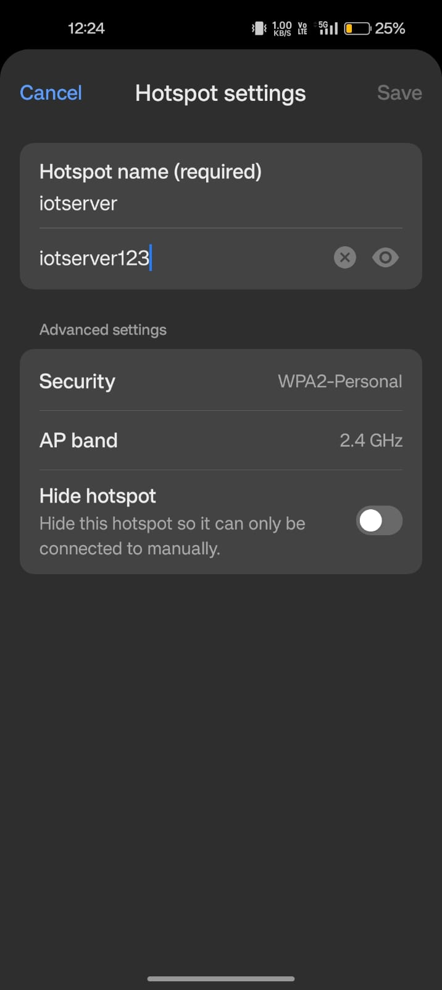

Figure 5.1 : WIFI READY.

After connecting wifi the LCD Display.

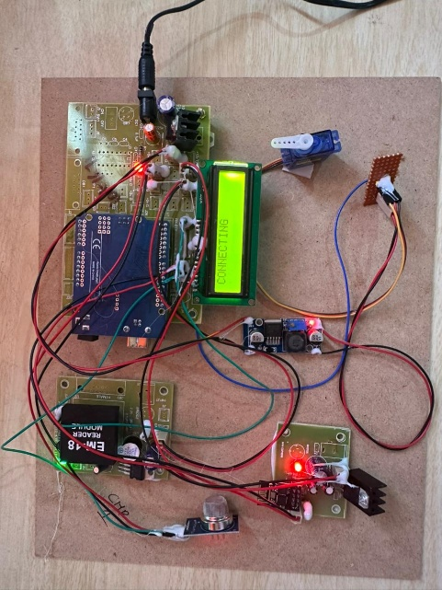

Reading data using RFID :

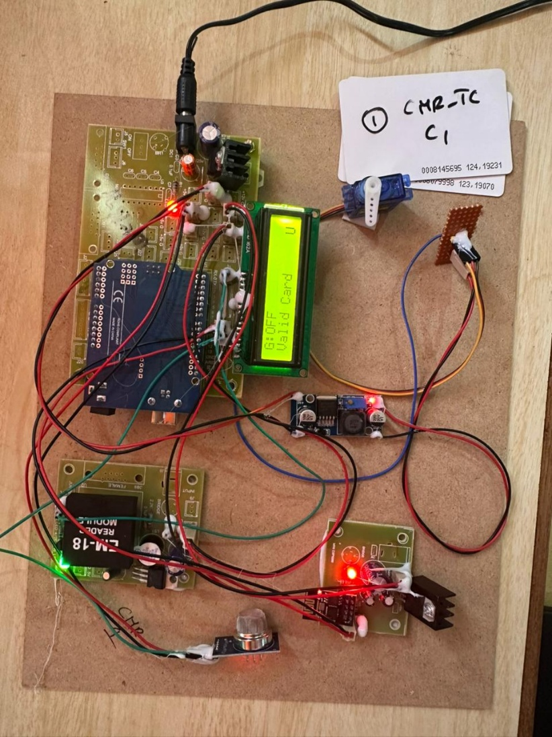

For Data Search in projectfactoryserver.in:

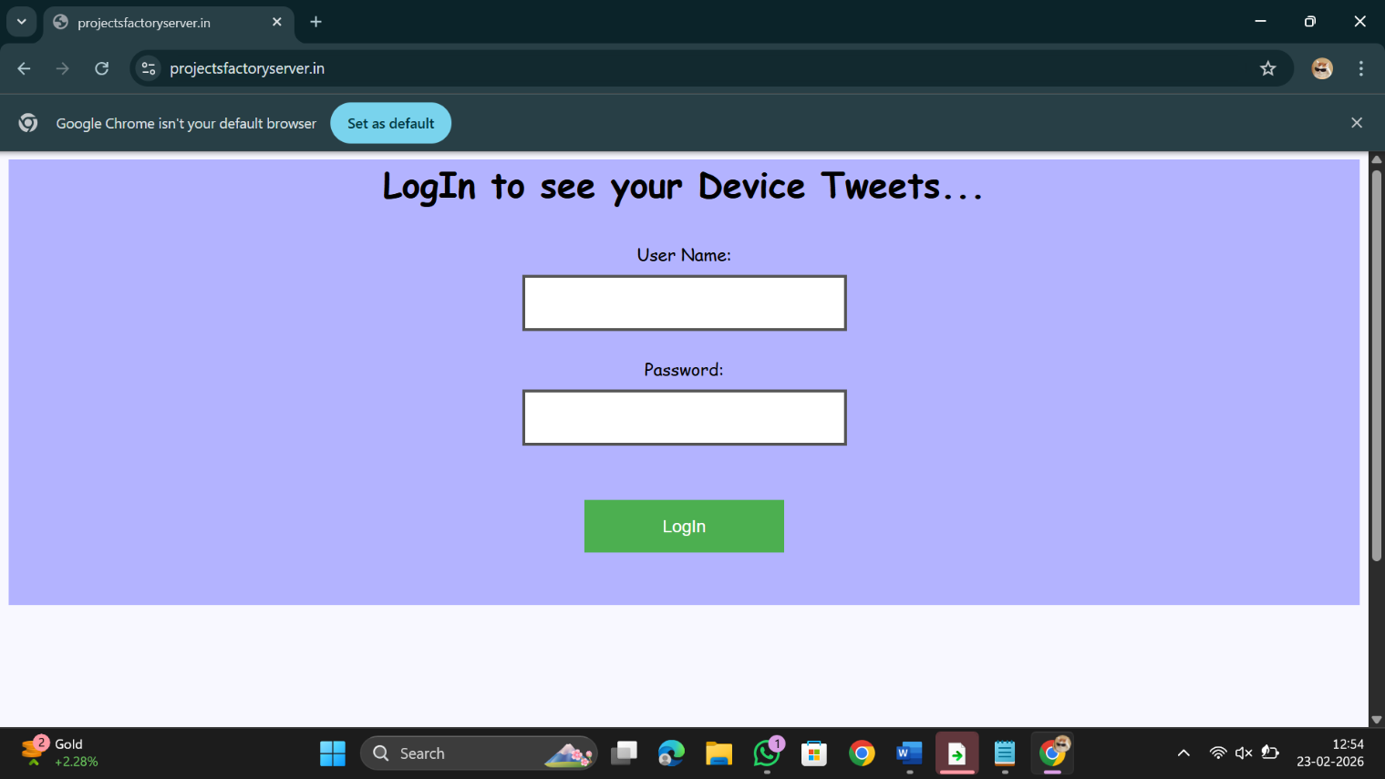

Display of data in the server:

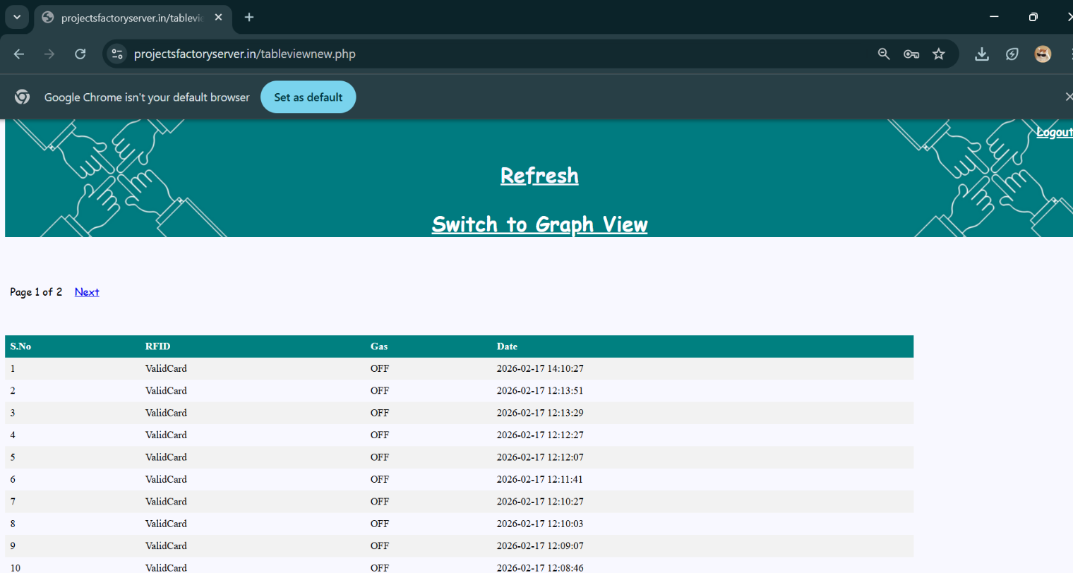

VALIDATION

VALIDATION

The validation of this project primarily relies on structured testing and performance evaluation to ensure the accuracy, reliability, and effectiveness of the RFID-based vehicle emission monitoring system integrated with the Maximum Spanning Tree (Max-ST) algorithm. The testing process includes multiple stages such as sensor data validation, algorithm verification, system integration testing, and real-time field simulation..

INTRODUCTION

Initially, the collected data from RFID readers, air quality sensors, and traffic density sensors is divided into training and testing datasets, typically using an 80–20 split. The training dataset is used to compute edge weights based on pollution level, traffic density, and high-emission vehicle count, while the testing dataset evaluates the accuracy of pollution hotspot identification. To improve reliability and avoid biased results, cross-validation techniques are applied across different time intervals and city zones, ensuring that the system performs consistently during peak hours, non-peak hours, and special events.
The performance of the system is measured using key evaluation metrics such as RFID detection accuracy, pollution hotspot detection accuracy, response time of the real-time monitoring system, false alert rate for emission violations, and system latency in data transmission. Confusion matrix analysis is used to assess correct and incorrect classifications of high-emission vehicles, helping refine emission threshold values and improve detection precision. Additionally, the Maximum Spanning Tree (Max-ST) approach is compared with traditional static traffic monitoring systems, demonstrating improved route-level pollution analysis and faster identification of critical emission corridors.
Finally, real-world deployment testing is conducted in simulated urban traffic environments to evaluate system stability under varying traffic densities and pollution levels. Continuous optimization is performed based on test results, including improvements in sensor calibration, edge-weight computation, and traffic rerouting strategies. This structured validation process ensures that the proposed RFID + IoT + Max-ST system is reliable, scalable, and capable of delivering accurate real-time vehicle emission monitoring and intelligent traffic management for smart cities.

CONCLUSION & FUTURE ASPECTS

CONCLUSION & FUTURE ASPECTS
In conclusion, the project presents an intelligent and automated solution for controlling vehicle emissions in urban areas by integrating RFID technology, IoT-based real-time monitoring, and the Maximum Spanning Tree (Max-ST) algorithm. The system efficiently combines vehicle identification, pollution data collection, and graph-based route analysis to detect high-emission vehicles and pollution-intensive corridors, improving traffic regulation and environmental management compared to traditional methods. With strong potential for large-scale smart city deployment, future enhancements such as AI-based predictive analytics and adaptive traffic control can further improve sustainability, optimize urban mobility, and ensure long-term scalability.

PROJECT CONCLUSION

This research presents a robust and scalable framework for reducing vehicular emissions by integrating RFID-based vehicle identification, IoT-enabled real-time pollution monitoring, and the Maximum Spanning Tree (Max-ST) algorithm for pollution hotspot detection. The system overcomes limitations of conventional traffic monitoring approaches by enabling automatic vehicle tracking, real-time emission data collection, and dynamic route-level pollution analysis.

By representing the city road network as a weighted graph and applying Kruskal’s algorithm to construct the Maximum Spanning Tree, the system efficiently identifies high-pollution corridors and prioritizes them for traffic optimization. The IoT infrastructure ensures continuous data transmission from RFID readers and environmental sensors to the cloud server, enabling instant violation detection and intelligent decision-making. Compared to traditional static traffic systems, the proposed model provides improved accuracy, reduced response time, and better enforcement of emission regulations.

The modular architecture of the system supports scalability and integration with smart city platforms, including intelligent traffic lights, congestion pricing systems, and electric vehicle prioritization. Overall, the project demonstrates practical feasibility, environmental benefits, and strong potential for sustainable urban transportation management.

7.2 FUTURE ASPECTS

The proposed RFID + IoT + Max-ST framework provides a strong foundation for smart emission control; however, several enhancements can further improve its performance and real-world applicability.

FUTURE ASPECTS
The proposed RFID + IoT + Max-ST framework provides a strong foundation for smart emission control; however, several enhancements can further improve its performance and real-world applicability.

Future Developments Include:
- AI-Based Predictive Pollution Modeling
Integrating machine learning algorithms to predict future pollution trends and traffic congestion.
- Real-Time Adaptive Traffic Signal Control
Using dynamic AI-based traffic management to automatically adjust signal timing based on pollution intensity.
- Integration with Electric Vehicle Infrastructure
Providing priority lanes and incentives for low-emission and electric vehicles.
- City-Wide Smart Dashboard Expansion
Developing advanced visualization tools with heatmaps and predictive analytics.
- 5G and Edge Computing Integration
Reducing latency and improving real-time responsiveness through edge-based data processing.
- Inter-City Data Sharing Network
Enabling collaborative pollution control strategies across multiple smart cities.
- Policy and Regulatory Integration
Supporting automated fine generation, congestion pricing, and green tax systems.
- Renewable Energy-Based Sensor Networks
Powering IoT sensors using solar or renewable energy for sustainability.
With continuous innovation and technological advancement, this system can evolve into a comprehensive smart transportation and environmental monitoring platform, contributing significantly to cleaner air, reduced traffic congestion, and sustainable urban development.

BIBLIOGRAPHY

BIBLIOGRAPHY

REFERENCES
- C. M. Wong, P. K. Wong, Z. Q. Ma & K. I. Wong, Application of RFID Technology and the Maximum Spanning Tree Algorithm for Solving Vehicle Emissions in Cities on Internet of Things, 2014 IEEE World Forum on Internet of Things (WF-IoT).
- Priya Y. Bhore & M. A. Mechkul, Resolving Vehicle Emissions in Cities by Maximum Spanning Tree Algorithm based on Internet of Things, Journal of Web Development and Web Designing, Vol. 1 No. 3, 2025.
- T. Leelaram & T. Ramya, RFID Based Vehicle Emissions in Cities on Internet of Things, International Journal of Research in Modern Engineering and Emerging Technology, Vol. 3, No. 2, 2015.
- G. Anil Kumar & T. Manoj Kumar, Application of RFID Technology for Solving Vehicle Emission in Cities on Internet of Things, IJARIIE, Vol. 14, Issue 10, Aug 2024.
- S. Jewargi & R. Durgale, RFID based Vehicle Emissions in Cities on Internet of Things, International Journal of Engineering Research & Technology (IJERT).
- R. Pavan Kumar & K. V. Murali Mohan, Solving Vehicle Emissions in Cities Based on RFID and GPRS/GSM Technology, International Journal of Research in Advanced Engineering Technologies, Vol. 4, Issue 5, 2015.
- C-M. Vong, P-K. Wong & W-F. Ip, Framework of Vehicle Emission Inspection and Control through RFID and Traffic Lights, Proceedings of the 2011 International Conference on System Science and Engineering (ICSSE), 2011.
- S. Manna, S. S. Bhunia & N. Mukherjee, Vehicular Pollution Monitoring using IoT, In Proc. IEEE International Conference on Recent Advances and Innovations in Engineering (ICRAIE), 2014.
- Chunxiao Li & Shigeru Shimamoto, ETC Assisted Traffic Light Control Scheme for Reducing Vehicle Emissions, International Journal of Managing Information Technology (IJMIT), Vol. 4, No. 2, May 2012.

